**Product & Plans Configuration in IBM APIC**

For configuration of product go to Products section in Develop tab.

Inside product there are 5 tabs :

1. Product setup
2. Visibility
3. APIs
4. Plans
5. Categories
6. Billings

## **Product Setup :**

Inside Product setup, we can see this type of UI :

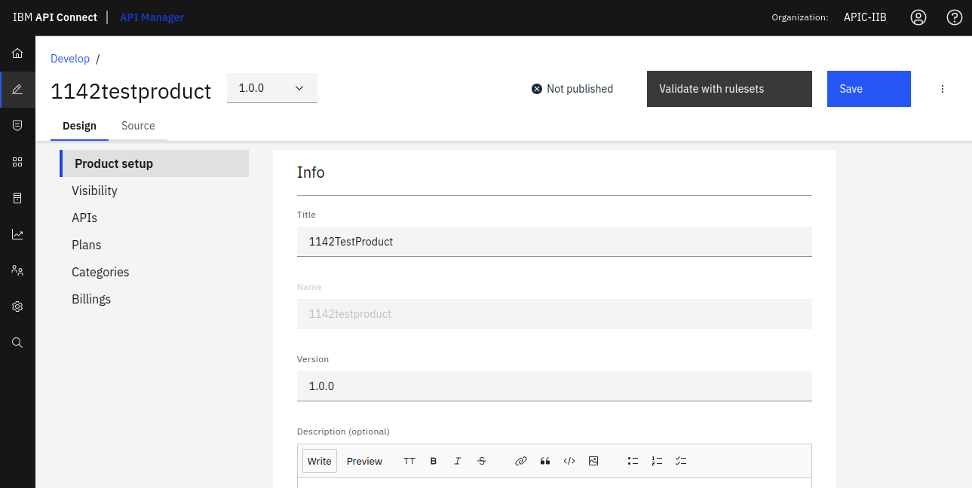

* **Title** : Here we can add a title for our product.
* **Name** : Here the Title of product will be taken as Name by default.
* **Version** : We can have multiple versions of same product based on our requirements.
* **Description** : Here we can add some more detailed description about our product.

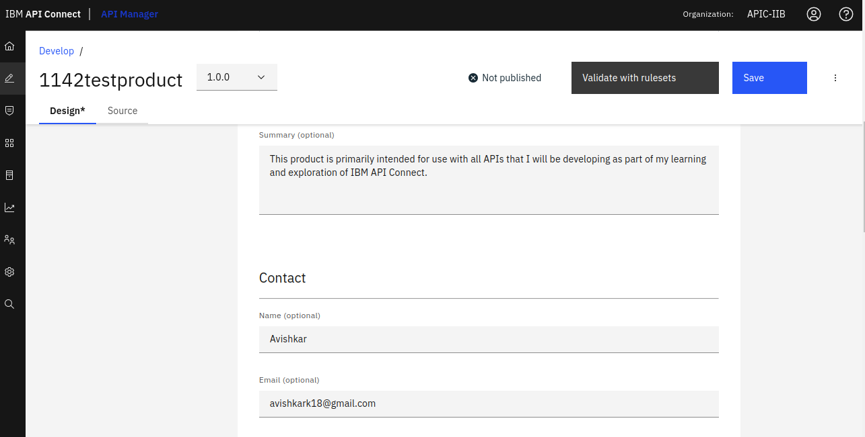

* **Summary** : Here we can summarize our products' use.
* **Contact** : Here we can provide contact details like name, email and any website link.

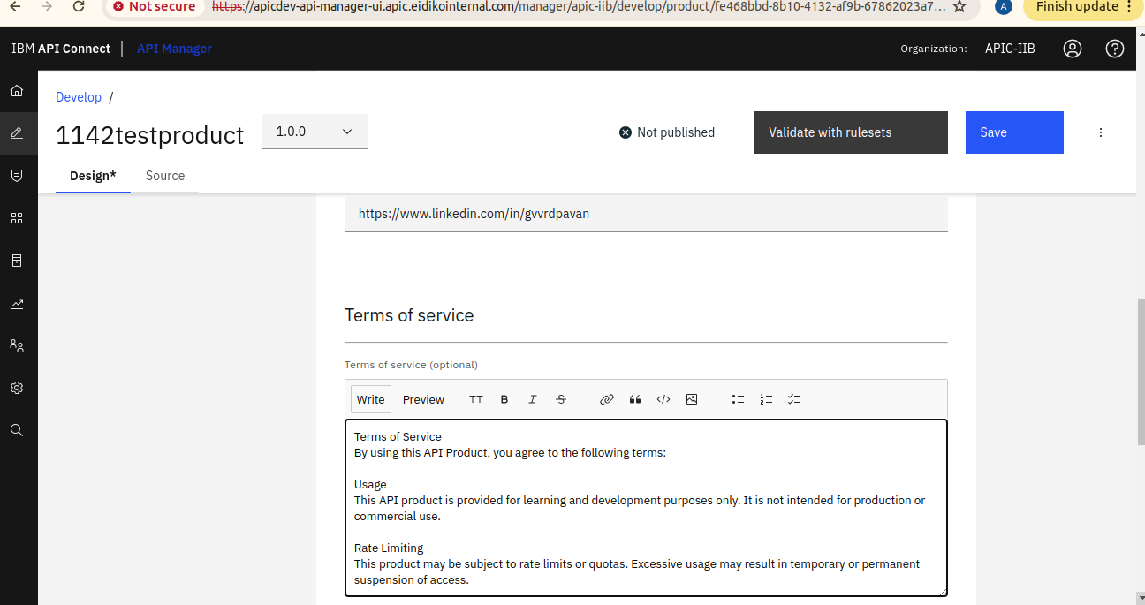

* **Terms of Service** : By using this API Product, you agree to the following terms given in this section.

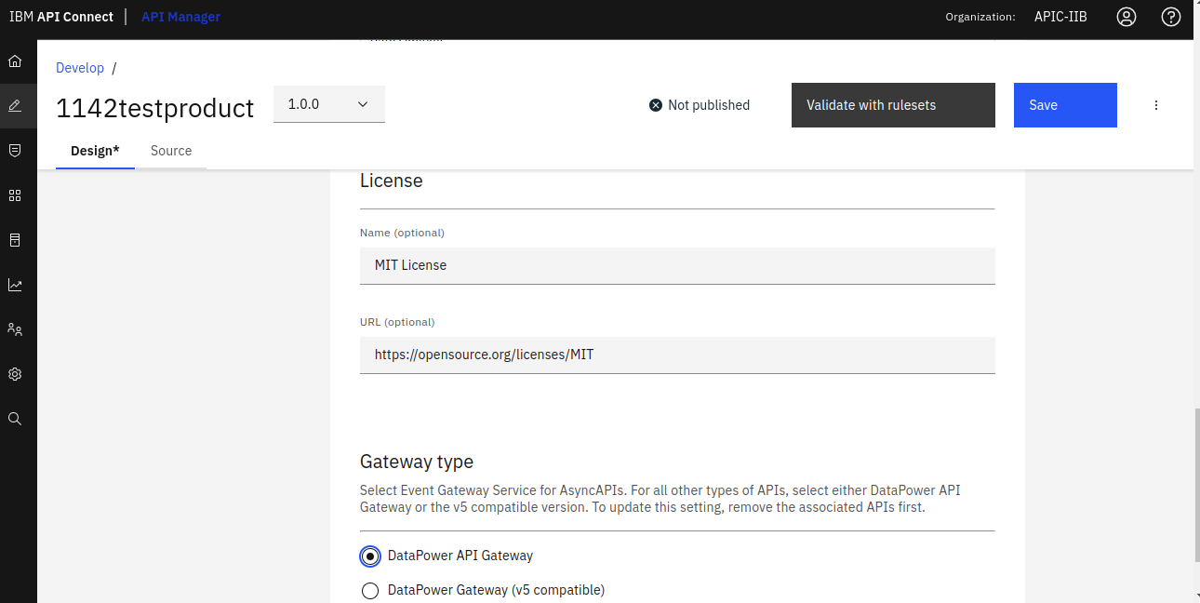

* **License** : License section under a Product defines the **legal terms** under which your API Product is provided to consumers. It's meant to inform developers or external users about how they can use the APIs legally.
* **Gateway type :** Here we can select the type of gateway which we want to use. Select Event Gateway Service for AsyncAPIs. For all other types of APIs, select either DataPower API Gateway or the v5 compatible version.

## **Visibility :**

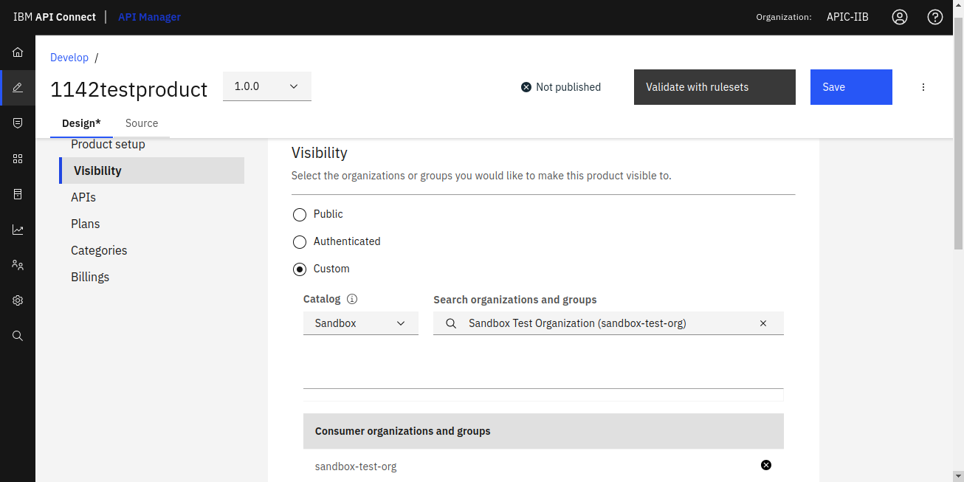

### **Visibility :** Determines who can *see* the API Product in the Developer Portal. It controls access to view the API documentation, plans, and other metadata.

There are 3 values can be selected inside Visibility section

1. **Public :** Anyone (including users who are not logged in) can view the API product in the Developer Portal.
2. **Authenticated :** Only users who are logged into the Developer Portal can view the product.
3. **Custom :** You specify exactly which Consumer Organizations can view the API product.

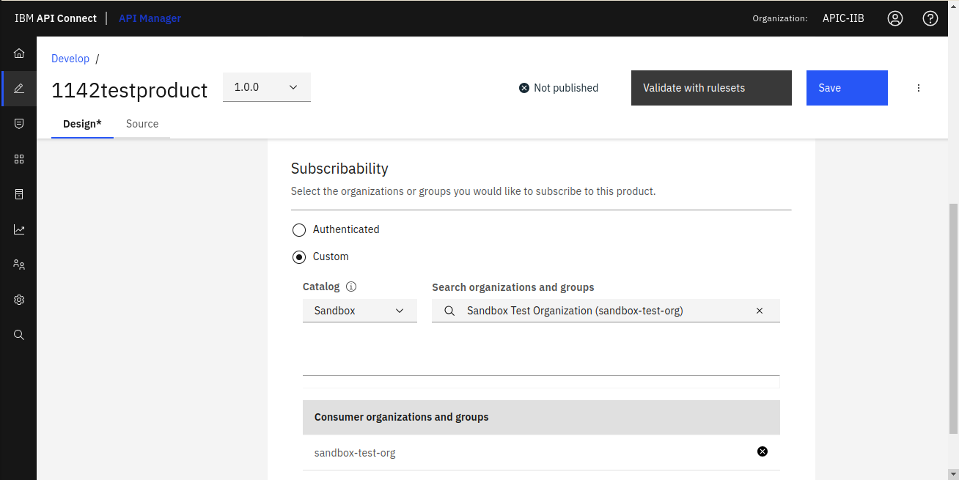

### **Subscribability** : Controls who can *subscribe* to an API plan (i.e., request access and get credentials like API keys). Subscribability can be open or restricted. It applies to Plans within the product, not the product itself.

Here we have 2 options :

1. **Authenticated** : Any logged-in user in the Developer Portal (from any consumer organization) can subscribe to this product plan.
2. **Custom** : Only specific Consumer Organizations can subscribe to the plan.

## **APIs :**

It will contains all the list of APIs which are present in that particular product.

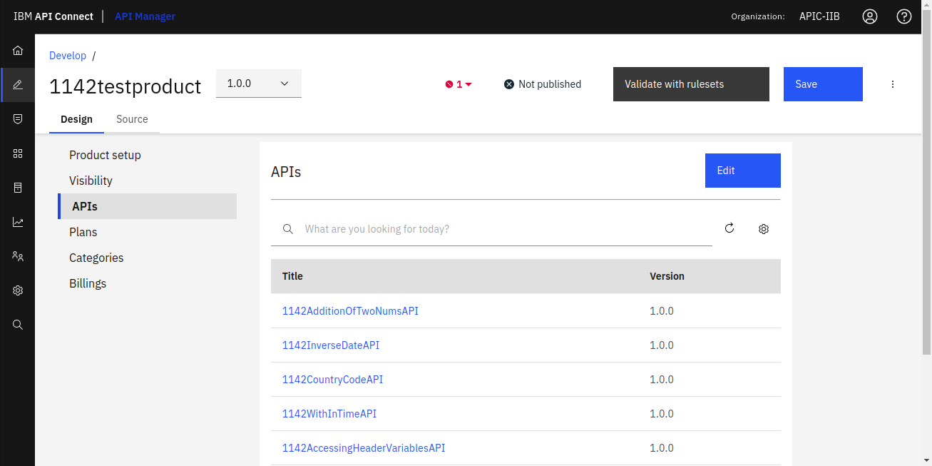

Here we can add any API into that product by checking the checkbox.

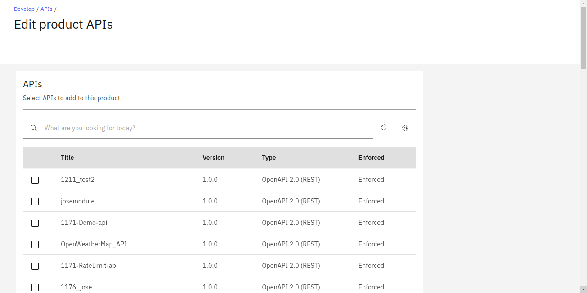

## **Plans :**

It contains a list of plans present in that particular product having different rate limits. For ex. Gold, Platinum, Silver etc.

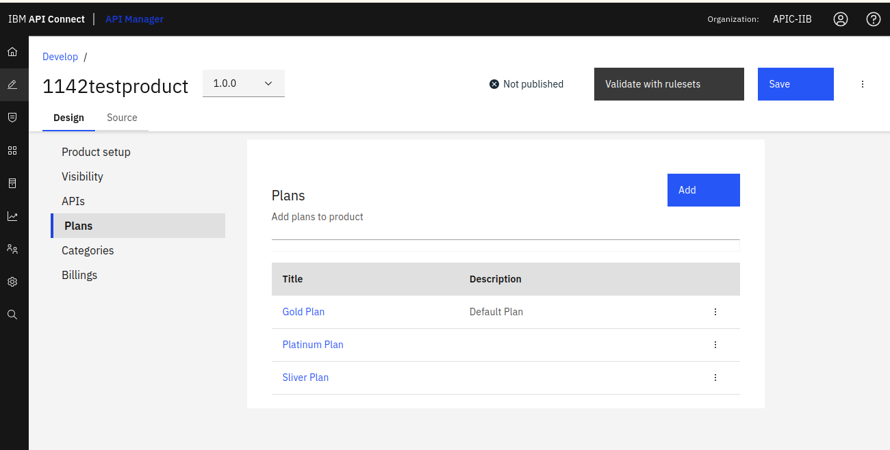

We can also add/edit plans to configure them according to our needs.

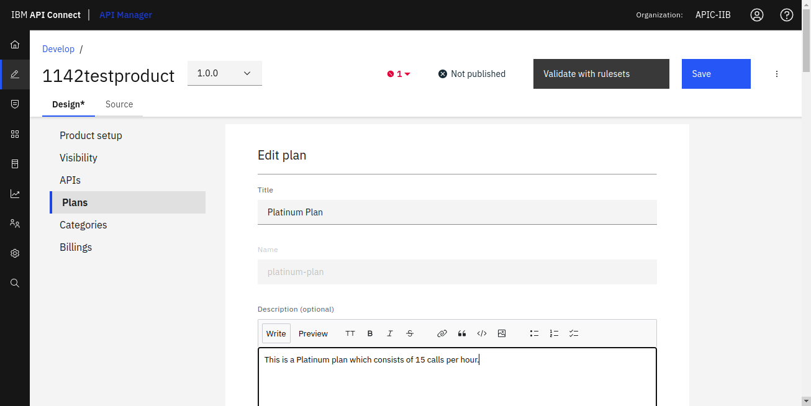

* **Title** : Here we can add a title for our plan.
* **Name** : Here the Title of plan will be taken as Name by default.
* **Description** : Here we can add some more detailed description about our plan.

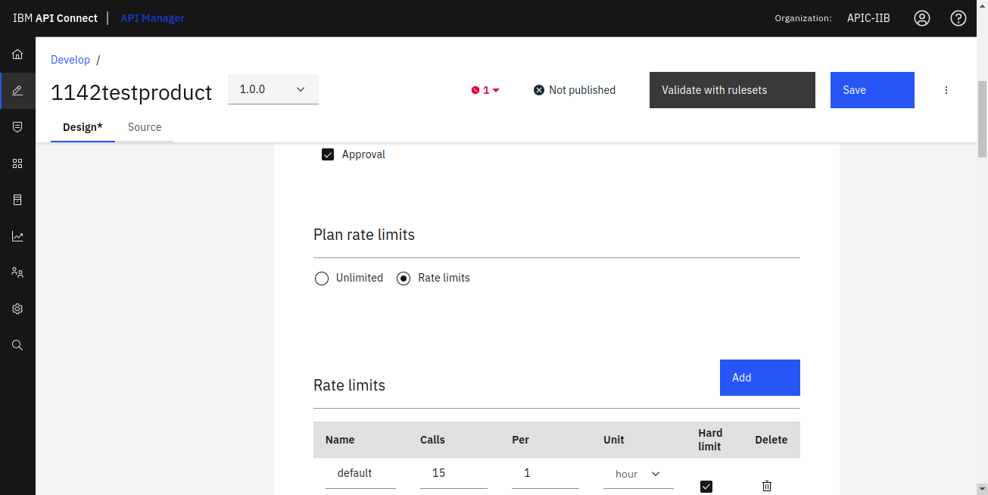

### **Approval** : When someone subscribes to the plan, the request goes into pending state and must be manually reviewed and approved by an admin or product owner.

### **Plan rate limits** : Plan Rate Limit defines how many times a consumer (app or user) can call an API within a specific time period. Here we can mention name of rate limit, no. of calls per unit time and also we can check the Hard Limit checkbox to strictly allow user to access the API only for the specified no. of times mentioned in Rate Limit otherwise the user will get 429 status code i.e. Too Many Requests.

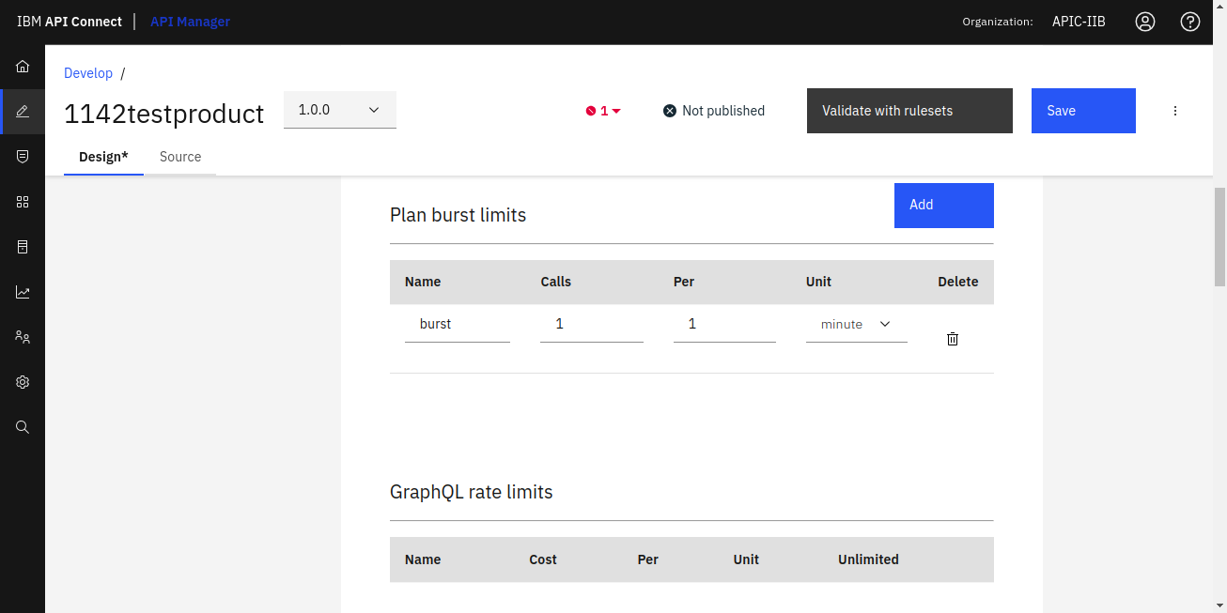

### **Plan burst limits :** Plan Burst Limit controls how many short-term spike requests a consumer can make in a very short time window, typically a few seconds or minutes. It complements the Rate Limit, which controls sustained usage over longer periods (e.g., per hour or per day).

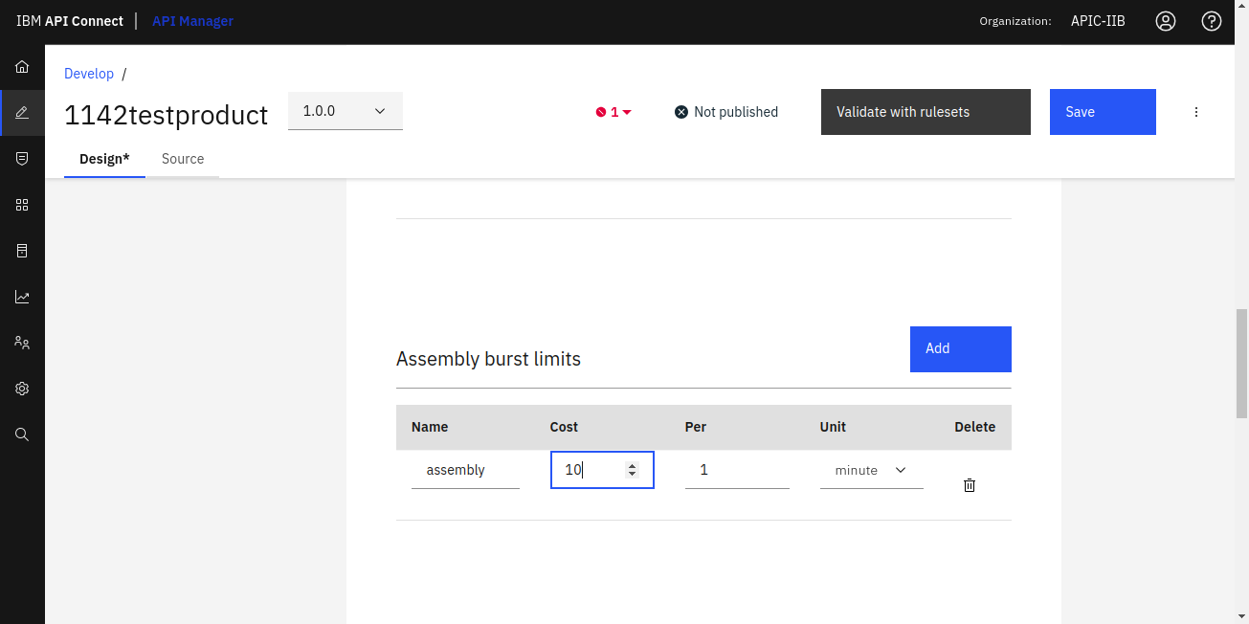

Also there Assembly burst limits (which decides cost per unit time) and Assembly count limits.

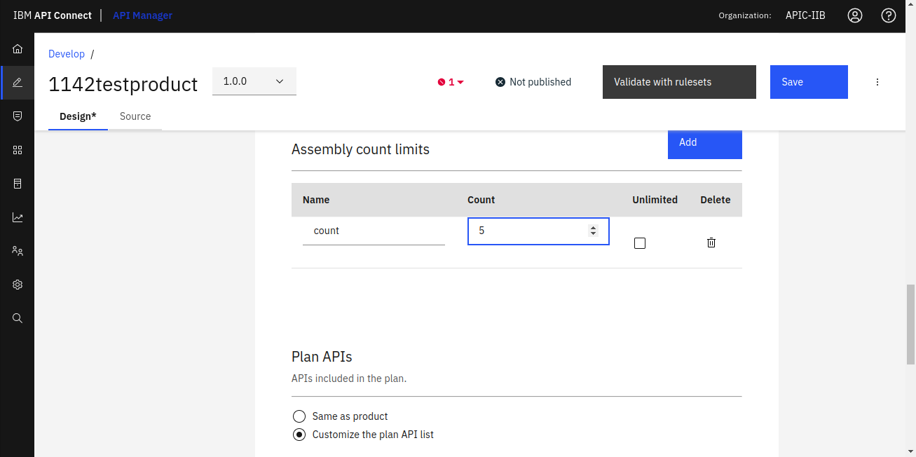

* **Plan APIs :** In this section we can include corresponding APIs in the particular plan. There are 2 options :

1. **Same as product** (All APIs present in product will be accessible through that plan).
2. **Customize the plan API list** (We can add particular APIs in that plan so that only that APIs will be accessible to the subscribers of that plan).

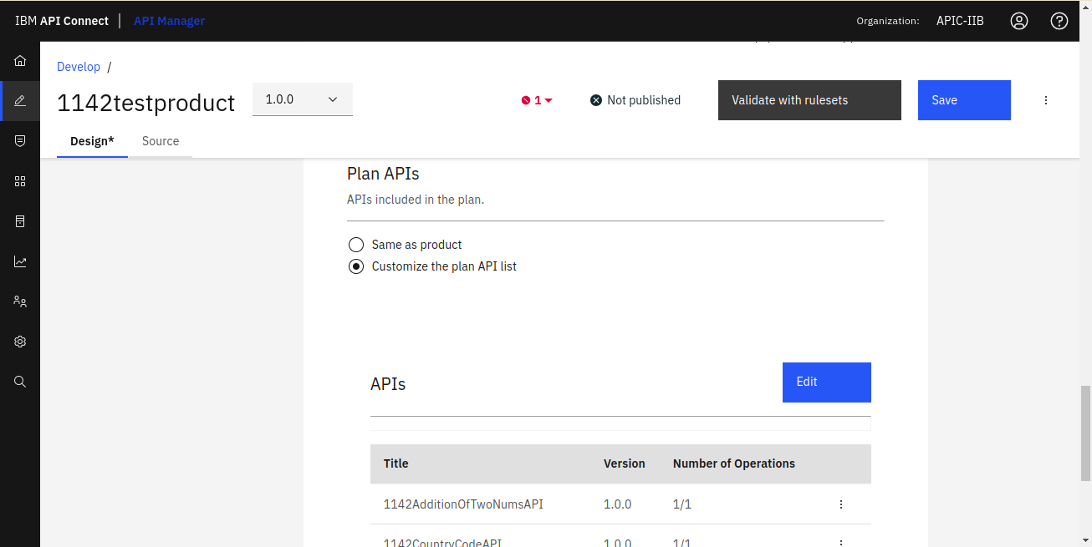

Here we can add or remove APIs which will be accessible through that plan.

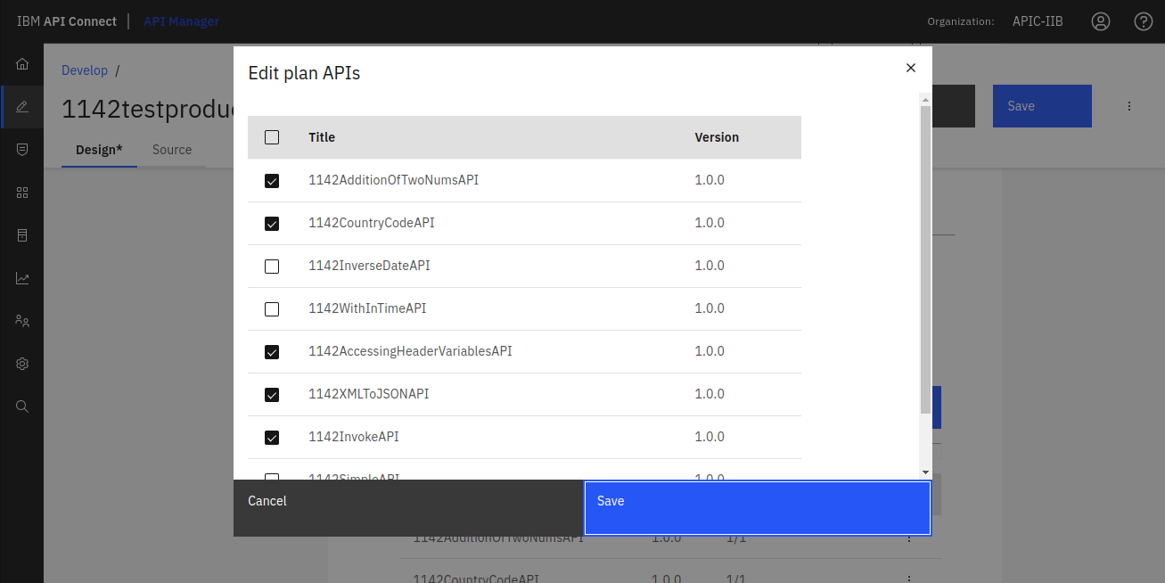

* **Override Rate Limits :** Here we can override the rate limits for individual operations present in an API service.

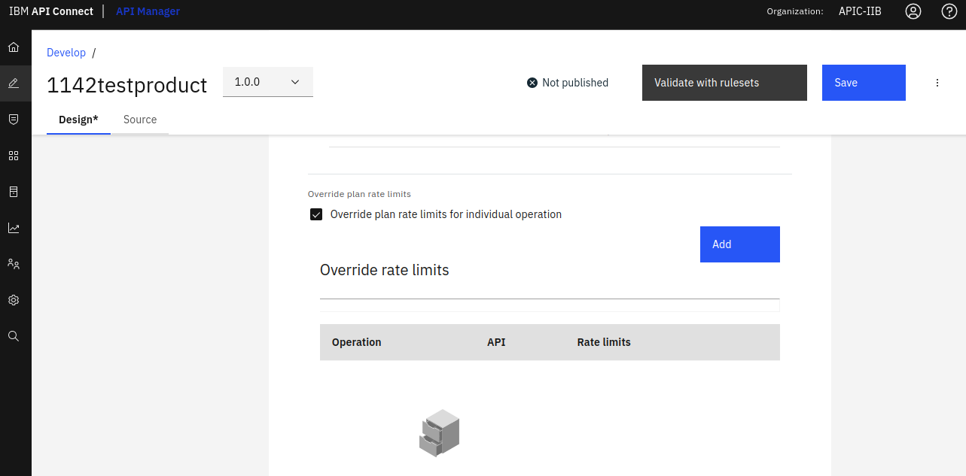

Here we can select the API, and any operation from that api to add rate limits to that particular operation.

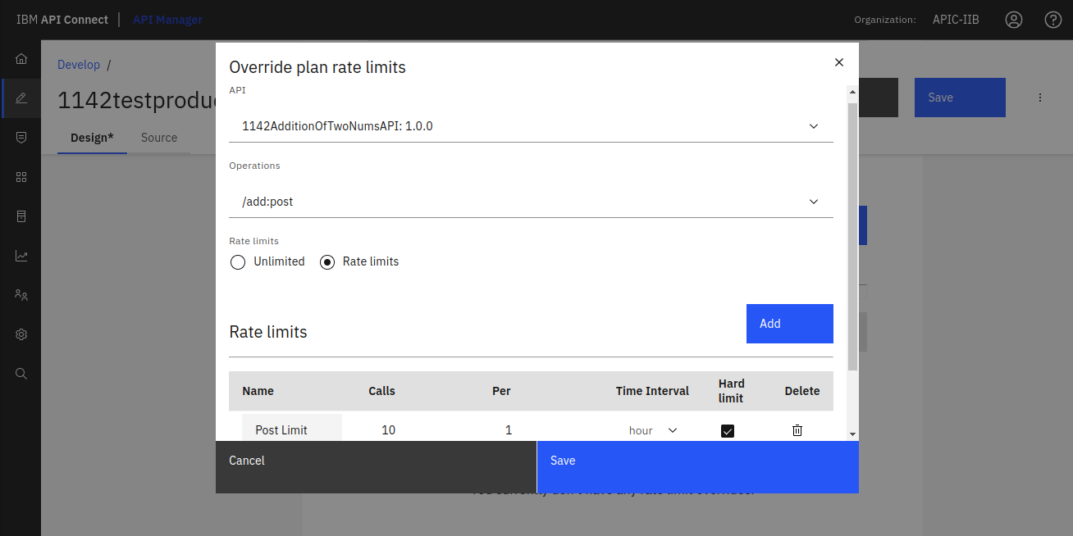

## **Categories :**

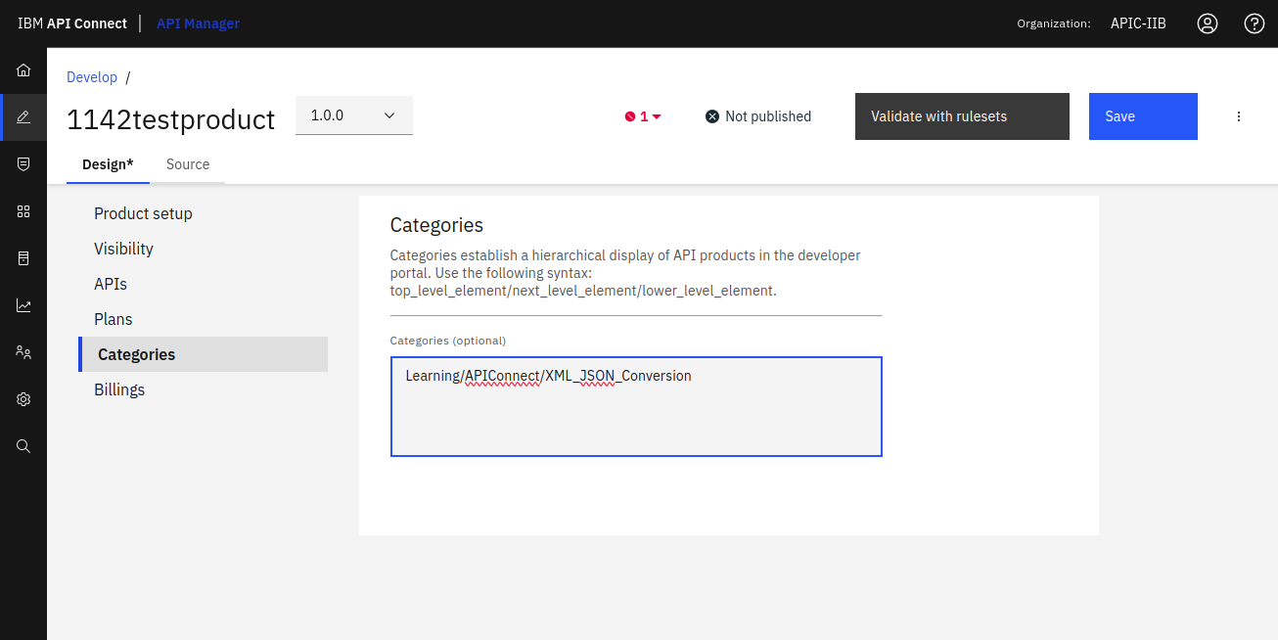

## **Billings :**

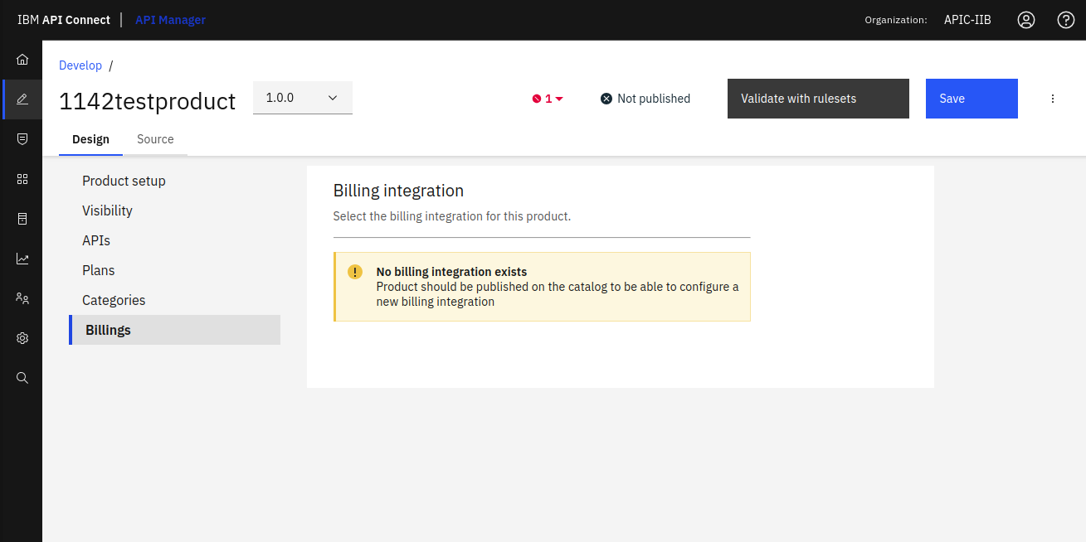

## **Observations**

1. **With Hard limit (10 calls / hour) & Burst limit (2 calls / minute) :**

After 2 calls, for the 3rd call we will get this error as the burst limit is set to 2 calls / minute.

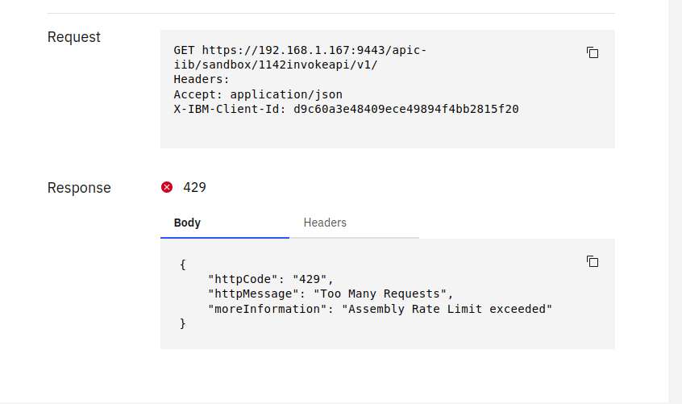

1. **Without Hard limit & Burst limit:**

We will not get any error as we haven't set any Burst or Hard limit.

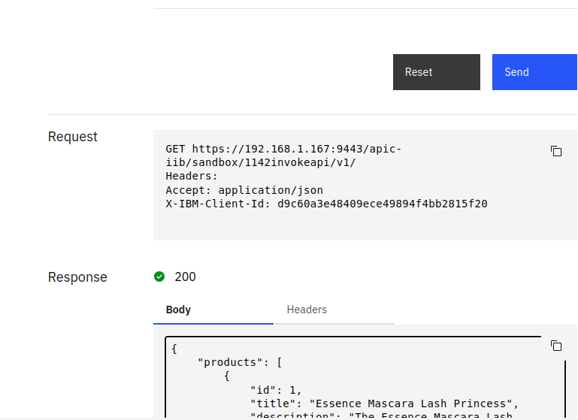

1. **With Hard limit (10 calls / hour), Without Burst Limit :**

After 10 calls, for the 11th call we will get 429 error as the Hard limit is set to 10 calls / hour.

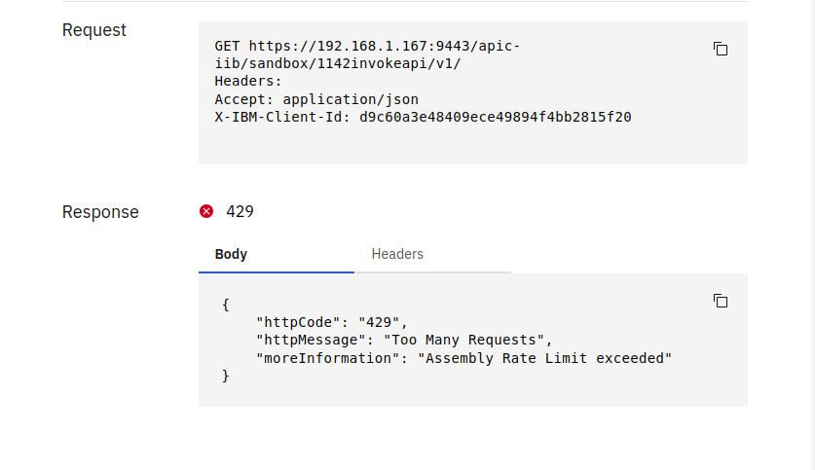

1. **With Burst limit (2 calls / minute), Without Hard limit :**

We will not get any error as we haven't set any Hard limit irrespective of setting burst limit to 2 calls / minute.

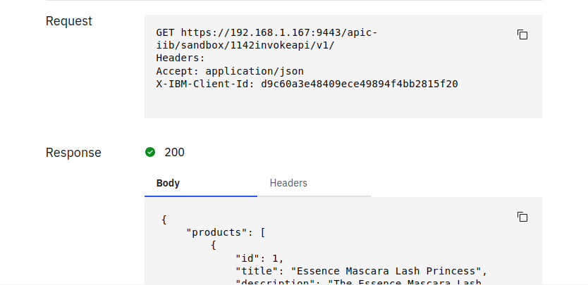

**Note :** Everytime after making any changes in a plan you need to publish the product to the catalog.

If you try to select another plan from same product to which you are not subscribed, then you will get this error. This error says **you can subscribe to only one plan in a product.**

